MULTISITE GRANT MANAGEMENT SYSTEM

IGNOU-MHRD Sakshat Proposal Evaluation

User Guide Document

-MGMS Ver. 1.9

Version History
Date | Description
18-Feb-2010 | First Draft

Table of Contents

Version History 2
1 Introduction 5
1.1 Purpose 5
2 Expense Request Evaluation 5
2.1 Initial Administrative Functions 5
2.1.1 Site Admin: Add New Role – ROLE_PROPOSALADMIN 5
2.1.2 Site Admin – Default approval authority 6
2.1.3 Site Admin – Notification creation for a grant scheme 6
2.2 Proposal Admin - Proposal evaluation Pre-settings 7
2.3 Public – applying for grant scheme 9
2.3.1 Reviewer – Proposal List 11

Table of Figures

Figure 1: Site admin - create default approval authority 6
Figure 2: Site admin - Create notification 7
Figure 3: Notification List 7
Figure 4: Site admin - Show notification 8
Figure 5; Site admin - Publish notification 8
Figure 6: Public - Notifications List 9
Figure 7: Proposal admin - Evaluation scale 9
Figure 8: Proposal admin - Evaluation scale options 10
Figure 9: Proposal admin - Evaluation Criteria 10
Figure 10: Public user - proposal form Part I 11
Figure 11: Public user - Proposal preview and submit 11
Figure 12: Public user - Proposal options after submission 12
Figure 13: Public user - Revision of submitted proposal 12
Figure 14: Reviewer - Proposal List 12
Figure 15: Reviewer - Proposal Preview 13
Figure 16: Reviewer - Proposal review and scoring 13
Figure 17: Reviewer – Reviewed Proposal List with scores 14

Introduction

Purpose

This document provides the step-by-step instructions for the various activities associated with final proposal evaluation for a client specified grant award, using the Multisite Grant Management System application.

This is a ‘living document’ and the specification will change, continuously, as the project proceeds. More details will be added and the existing information edited as the requirements, architecture and design evolve in the course of the project.

Final Proposal Evaluation

Proposal evaluation including the following features:
- Calculation by which the average score is arrived at, for each proposal and the score display.
- A proposal may be resubmitted any number of times and a parameter V<x> will indicate the corresponding version number (x= 1, 2, 3 etc). The reviewer can review the latest proposal in the system.
- On final submission of proposal, an alert e-mail is sent to all members of the default approval authority (of the sponsoring institution) – currently a simple mail format is used
- Proposal Admin role is assigned to the person who will capture the evaluation details – parameters and criteria to judge , scoring pattern, questionnaire etc
- All scores to be viewable by Proposal Admin. Final scores will be viewable by reviewers at any point of time and each can edit own scores
- Proposal status request– user is prompted to enter the control number, once the submit button is clicked, the complete details of the proposal submitted is displayed:

Initial Administrative Functions

Site Admin: Add New Role – ROLE_PROPOSALADMIN
If not already saved in the application, this role needs to be saved and assigned to the user who needs to receive all evaluations from all the reviewers. Only a single person in an institute may be assigned this role. (In future the role may be assigned to each grant scheme for which proposals are called.).

Site Admin – Default approval authority

Default approval authority must be assigned for the institution. In this way, proposals submitted for all notifications will be directly sent for review to the members of the default approval authority. There can be only one default authority per institution

Figure 1: Site admin - create default approval authority
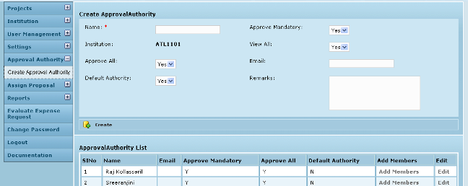

Site Admin – Notification creation for a grant scheme

In Call for Proposal sub menu of Projects Menu, the site administrator creates a new notification. Please note that in this document we are explaining the process for publically solicited proposals. So the notifications created are assigned the attribute “Public – Yes”. This means that the notification gets displayed in a Notification List made available outside the MGMS application as well.

Figure 2: Site admin - Create notification
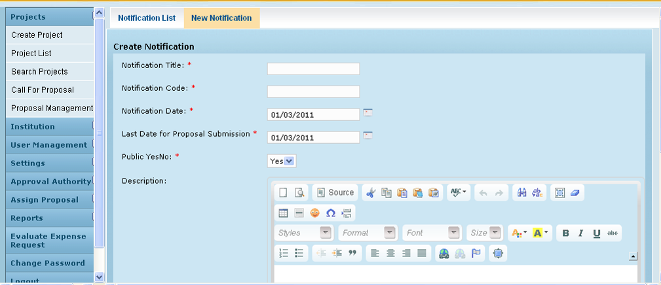

The details of all notification created are displayed as line items in the Notification List. (Fig 3 below)
Figure 3: Notification List
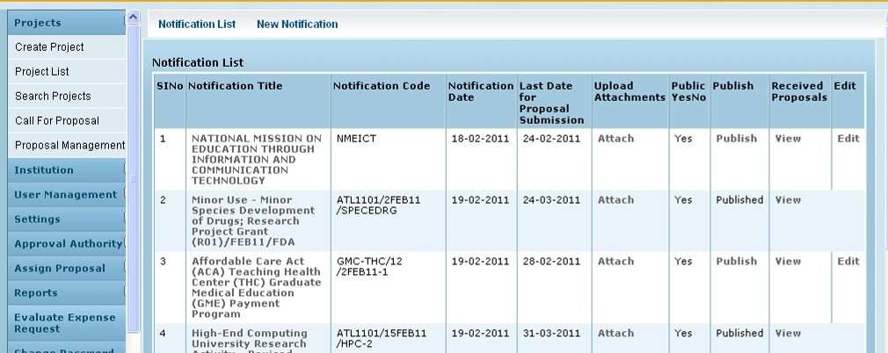
On clicking on a Notification Title, the details are displayed as shown in Fig 4. By clicking Edit, the details maybe modified through a new screen. Please note that once published, a notification cannot be edited.

Figure 4: Site admin - Show notification
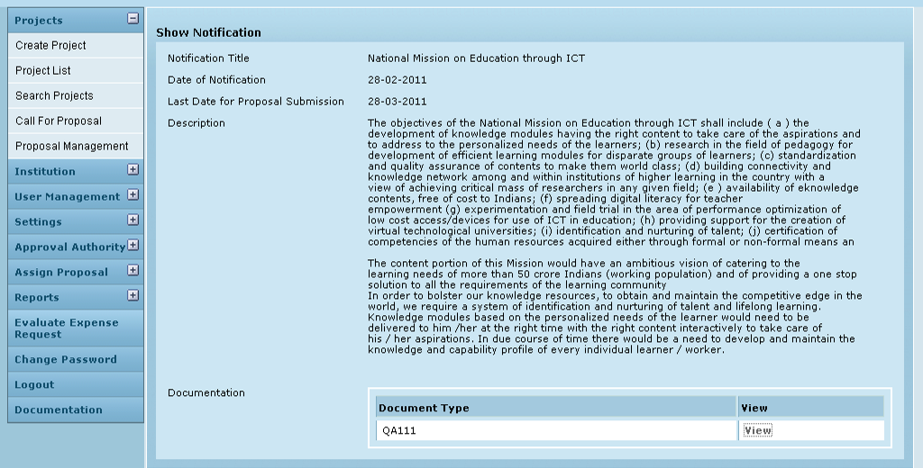
On clicking View, the attached document with more notification details can be opened in a separate window.
By clicking Call for Proposal access the Notification List screen, as shown below.
Once satisfied with the final draft, he Publishes the notification to announce to all private/public viewers that proposals are invited for the particular grant scheme.

Figure 5 Site admin - Publish notification
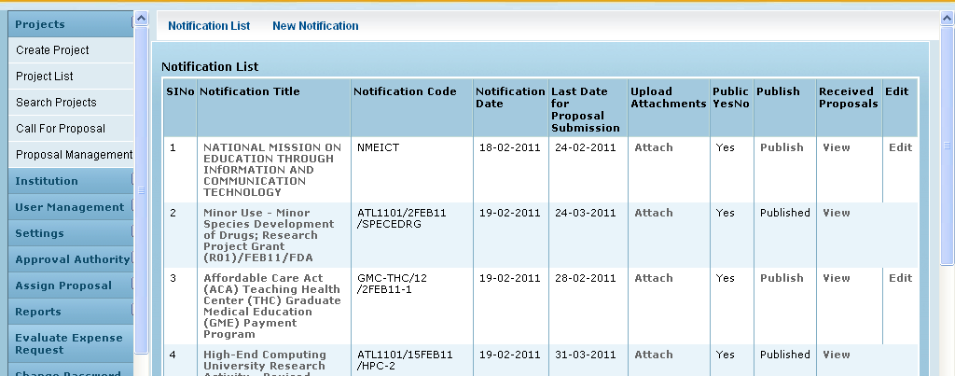

Once published the notification can be viewed outside the MGMS application – by clicking on Upload Proposal in the MGMS log in screen – shown in the figure below:
Figure 6: Public - Notifications List
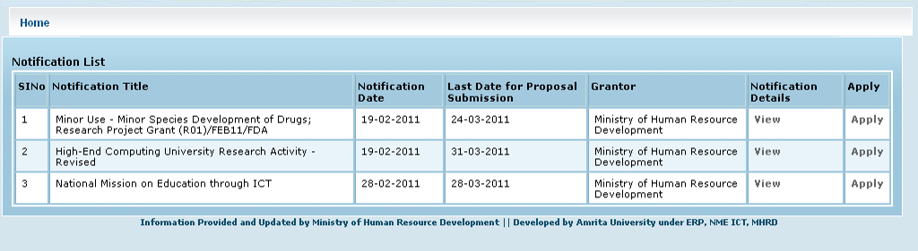

Now anyone may read and download notification details (attachment) and Apply for the particular grant scheme

Proposal Admin - Proposal evaluation Pre-settings

As mentioned before, the proposal administrator is in charge of various managing the evaluation process. For each grant notification created and published by an institution, the proposal admin assigns the specific evaluation parameters; ratings required and prepare the questionnaire for use by the reviewers.

After logging in, the user clicks on menu Proposal evaluation – pre settings, and sub menu Eval scale. Here the user can create a new evaluation scale as well as view all the scales created in this institution till now. Edit option is also provided to modify any existing scale’s name.

Figure 7: Proposal admin - Evaluation scale
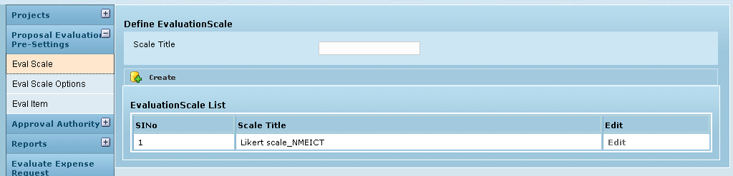

After naming the scale, the user clicks Eval Scale Options where the standard scores can be listed. For e.g. if the reviewer selects the option “Good” as per the Likert scale shown in the image below, for a particular answer , then the asnswer has scored 3 marks.
In case the user wants to score in number format, a new scale can be defined where Scale option “10” can be assigned Scale option index “10” .

Figure 8: Proposal admin - Evaluation scale options
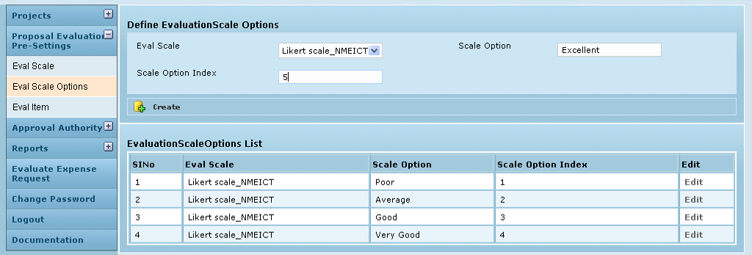

Once the scoring pattern is decided, the user clicks on Eval item, to add the criteria or questions for judging the proposals submitted for a particular notification.
As can be seen below, 7 questions are assigned to the notification code “NMEICT” and the Eval Scale used will be “Likert scale”

Figure 9: Proposal admin - Evaluation Criteria
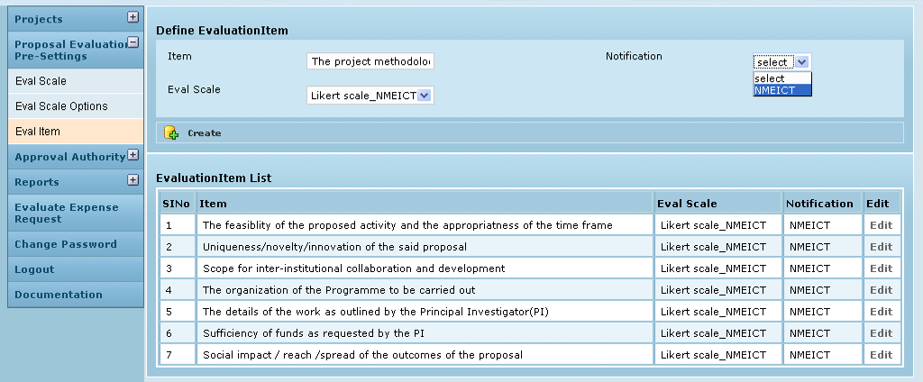

Public – applying for grant scheme

An applicant applies for the particular scheme by clicking “Apply” for the notification (Fig 6 ). Currently, the same 7 page form of IGNOU Sakshat has been made available for all institutions and notifications.
Figure 10: Public user - proposal form Part I
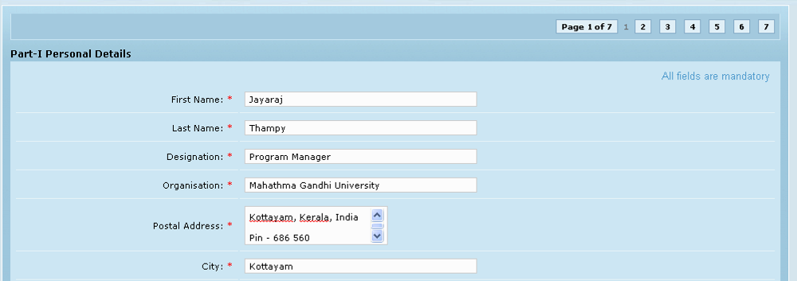

In Fig 11 below, is the preview page after filling on all 7 pages.

Now on clicking Finish, the proposal is officially submitted for evaluation as version V0.

On trying to open the proposal again by submitting the control id, the system displays message that it is already submitted (Fig 12) and the user is provided with 3 options (Links) –

Details provided by you – opens the Preview page
Enter revised proposal – opens Revision of Proposal screen where the user has to select “I agree” option to open the Preview – Edit page
Upload Proposal – opens new proposal form to start again

On clicking Enter revised proposal link, screen opens where the user has to select “I agree” option and click Submit to open the Preview – Edit page (Fig 13)

Figure 11: Public user - Proposal preview and submit
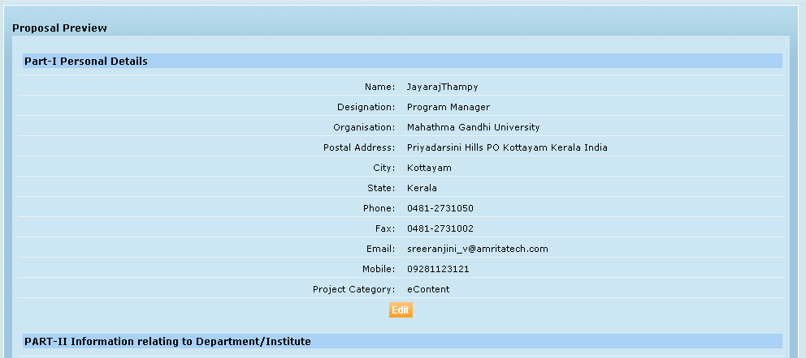

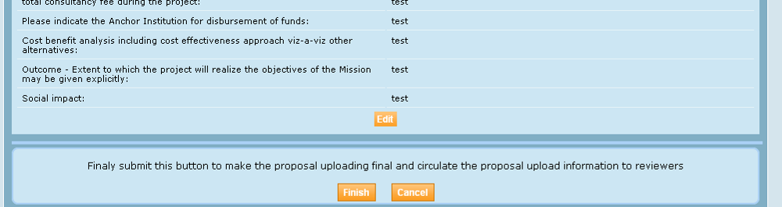

Figure 12: Public user - Proposal options after submission
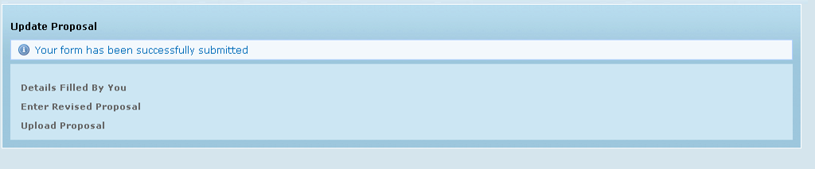

Figure 13: Public user - Revision of submitted proposal
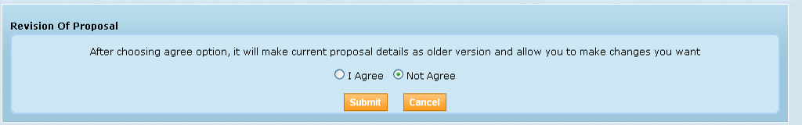
After making the necessary changes and updating the proposal, the user can click Finish. The version number of proposal changes, each time a proposal is revised in this manner.
On final submission of the proposal, it is available for evaluating in the log-ins of all reviewers who are part of the institution’s default approval authority.

Reviewer – Proposal List

The reviewers who belong to the default approval authority can see the proposal as a line item in their Proposal List (Fig 14).

Figure 14: Reviewer - Proposal List
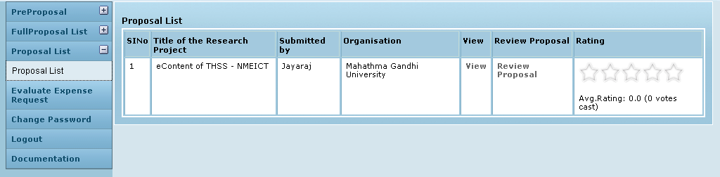

On clicking View, the preview page of the proposal is opened up. (Fig 15)

Figure 15: Reviewer - Proposal Preview
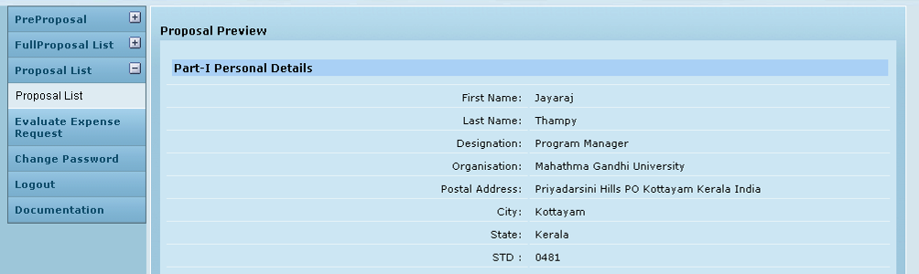

On clicking Review Proposal (Fig 14) for a particular proposal, the following screen opens up – Fig 16). Top portion of the screen displays the entire proposal in the preview format, and the bottom half displays the questionnaire to be used for evaluation of the proposal. Maximize button has been provided for both sections in case the user wishes to view the complete sections separately.
This was the questionnaire created by the proposal administrator initially (section 2.2 – Proposal evaluation – pre settings).
Please note that there maybe n number of reviewers and so at any point of time, a score will be displayed averaging the scores that have been assigned till then by one or more reviewers.

Figure 16: Reviewer - Proposal review and scoring
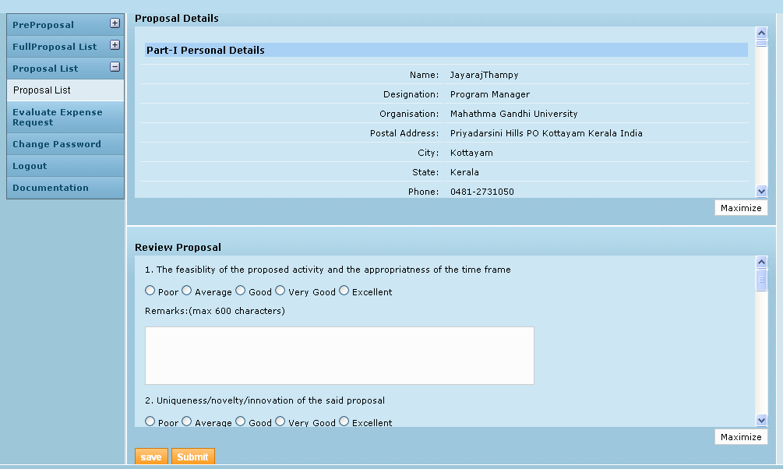

Each reviewer puts the score as deemed fit for the particular proposal and may enter any comments. It is mandatory that all questions be answered. Clicking Save will just save the details as draft. On clicking Submit, the scores are officially submitted into the system for calculation of the final score for the proposal. Given below is a sample list.

Figure 17: Reviewer – Reviewed Proposal List with scores
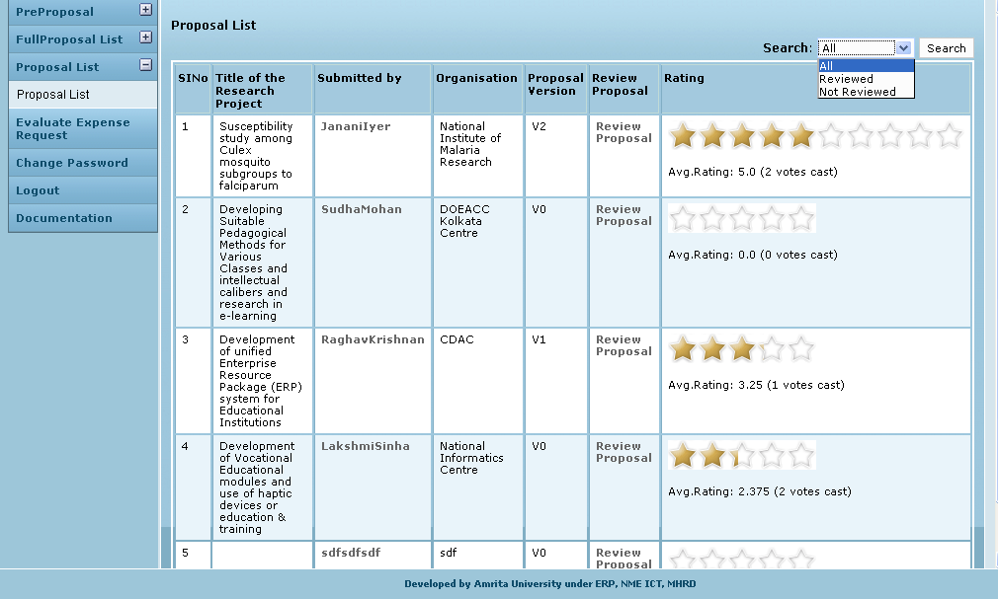

The final rating of the proposal is calculated as the average score. Currently, all reviewers can see the final score and the number of votes cast which resulted in that final score. “Votes cast” is the number of reviewers who have reviewed the proposal.
The Proposal admin and Site admin can also view the same list of scored proposals in the Projects menu, Call for proposal sub-menu. In the Notification List, clicking View in Proposal column for a particular notification will open the page displaying the proposals that were submitted against the notification and their final scores at any point of time.

